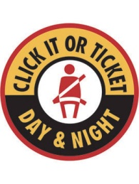
Virginia Highway Safety Office
Click It or Ticket
2016 Leadership Award
Nomination Form

Leadership Award

The Seat Belt Leadership Award recognizes a law enforcement officer who went above and beyond his or her normal duties during the Click It or Ticket 2016 May Mobilization. Award winners are those who made aggressive enforcement efforts during the Click It campaign, along with promoting seat belt use and proper child safety seat use, to the public and community through education and outreach.

The following individual is hereby nominated for the Leadership Award:

Nominee’s Information:

Name and title:

Agency:

Phone Number:

Email address:

Number of sworn officers (agency size):

Brief description of why this individual should receive a seat belt Leadership Award:

Nominator Information:

Your name and title:

Phone number:

Email address:

Submit nominations by August 12, 2016 to:
John.Messina@DMV.Virginia.gov
804-367-6031 (fax)
Attn. John Messina, Room 405
Virginia Department of Motor Vehicles
Virginia Highway Safety Office
2300 West Broad Street
Richmond, Va. 23269

