
VIRGINIA ASSOCIATION OF CHIEFS OF POLICE
1606 Santa Rosa Road, Suite 134
Richmond, Virginia 23288
Phone: 804-285-8227
Fax: 804-285-3363
E-mail: dana@vachiefs.org
www.vachiefs.org
Contact: Ms. Dana Schrad, Executive Director
Mobile: (804) 338-9512
June 21, 2011 – FOR IMMEDIATE RELEASE

2010 Virginia Law Enforcement Challenge Awards Announced
For Best Traffic Safety Programs in Virginia

The Virginia Association of Chiefs of Police (VACP) is pleased to announce the recipients of the 2010 Virginia Law Enforcement Challenge awards for the best traffic safety programs in the state. The awards luncheon will take place during the VACP’s 86th Annual Training Conference to be held September 25-28, 2011 at the Norfolk Waterside Marriott.
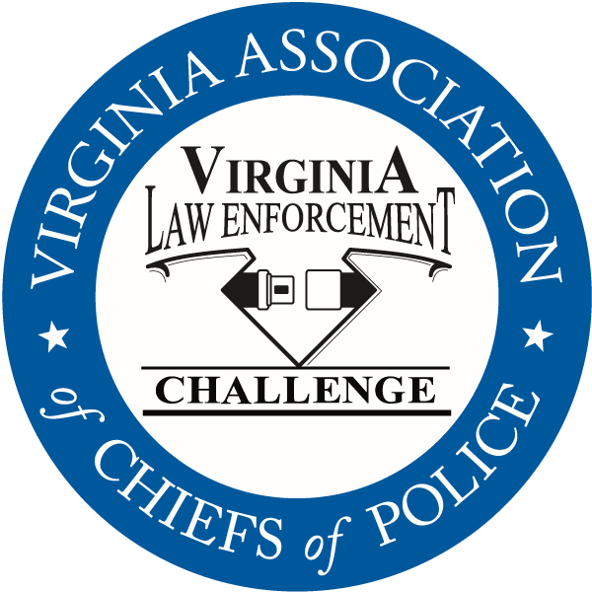
Celebrating its twenty-second year in Virginia, the Law Enforcement Challenge program promotes professionalism in traffic safety enforcement and encourages agencies to share best practices and programs with each other. The awards are based on entries prepared by the participating agencies that highlight their traffic safety education and enforcement activities in the past calendar year. Judges award points to the agencies in the six areas that comprise a comprehensive traffic safety program: an agency’s policies and guidelines, training of officers, incentives and recognition, public information and education, enforcement, and an evaluation of the effectiveness of the agency’s efforts.
The Virginia Challenge is held in cooperation with the National Law Enforcement Challenge Awards, which are presented by the International Association of Chiefs of Police (IACP). This year, fifty-one Virginia agencies entered the state and national competitions. Thirty-nine will receive state awards and 11 will receive national awards. National Challenge award winners have been announced by the IACP on their web site at http://www.theiacp.org/NLEC. The Virginia Beach Police Department has been named as the National LEC Clayton J. Hall Memorial Award Winner for having the most comprehensive traffic safety program in the country. The VACP is also a National Challenge Awards first place winner among state associations, being one of the few in the country that plays an integral role in their state’s highway safety efforts. National awards will be presented in October at the International Association of Chiefs of Police Annual Conference in Chicago, IL.
Virginia agencies will be presented with their state Challenge first, second and third place awards in each category at the luncheon in September, as well as special awards for outstanding enforcement and education efforts in the areas of occupant protection, impaired driving, speed awareness, child passenger safety, underage alcohol awareness and many more. Additionally, the VACP will announce the most outstanding traffic safety program in Virginia in 2010 regardless of agency size or type — the “Commonwealth Award” — and the 2010 Virginia Traffic Safety Officer of the Year Award, presented to an officer who has gone above and beyond to promote highway safety in his community.
The Virginia Law Enforcement Challenge Awards program is supported by a grant from the Virginia Highway Safety Office. Additional information about the Law Enforcement Challenge program can be found online at http://www.smartsafeandsober.org/programs/LEC.
The Virginia Association of Chiefs of Police is a statewide organization of federal, state and local police chiefs and law enforcement executives dedicated to improving the professionalism of police agencies in Virginia. The Association was founded in 1926 and has more than 600 members. For more information, visit http://www.vachiefs.org.
The winners of the 2010 Virginia Law Enforcement Challenge are as follows (* denotes National winner):
MUNICIPAL POLICE
Municipal 1: 1-10 Officers | Place
New Market Police Department | 1
Berryville Police Department | 2
West Point Police Department | 3
Municipal 2: 11-25 Officers | Place
Bedford Police Department | 1
Ashland Police Department | 2
Purcellville Police Department | 3
Municipal 3: 26-50 Officers | Place
Culpeper Police Department | 1
South Boston Police Department | 2
Front Royal Police Department | 3
Municipal 4: 51-75 Officers | Place
Christiansburg Police Department | 1
Herndon Police Department | 2
Blacksburg Police Department | 3
Municipal 5: 76-125 Officers | Place
Harrisonburg Police Department * | 1
Albemarle County Police Department | 2
James City County Police Department | 3
Municipal 6: 126-300 Officers | Place
Lynchburg Police Department | 1
Danville Police Department | 2
Portsmouth Police Department | 3
Municipal 7: 301-450 Officers | Place
Arlington County Police Department * | 1
Chesapeake Police Department | 2
Newport News Police Department | 3
Municipal 8: 451-700 Officers | Place
Henrico County Division of Police * | 1
Chesterfield County Police Department | 2
Municipal 9: 701+ Officers | Place
Virginia Beach Police Department * | 1
Fairfax County Police Department | 2

UNIVERSITY POLICE | Place
Virginia Commonwealth University Police Department | 1
University of Richmond Police Department | 2

MILITARY POLICE | Place
Fort Lee Police * | 1

SHERIFF’S OFFICES
Sheriff 1: 1-10 Deputies | Place
-- no entries in this category -- | --
Sheriff 2: 11-25 Deputies | Place
New Kent County Sheriff's Office * | 1
Sheriff 3: 26-50 Deputies | Place
Wythe County Sheriff's Office * | 1
Sheriff 4: 51-75 Deputies | Place
Augusta County Sheriff’s Office * | 1 (tie)
Dinwiddie County Sheriff's Office | 1 (tie)
Amherst County Sheriff's Office * | 2
Sheriff 5: 76-125 Deputies | Place
Washington County Sheriff's Office | 1
Fauquier County Sheriff's Office | 2
Sheriff 6: 126-300 Deputies | Place
Stafford County Sheriff's Office * | 1
Hanover County Sheriff's Office | 2
Spotsylvania County Sheriff's Office | 3
Sheriff 7: 301-450 Deputies | Place
-- no entries in this category -- | --
Sheriff 8: 451-700 Deputies | Place
Loudoun County Sheriff's Office | 1

STATE ASSOCIATIONS (National Challenge Only) | Place
Virginia Association of Chiefs of Police * | 1

SPECIAL AWARDS
“Rookie of the Year” Award | N/A, no first-time entries this year
Occupant Protection Award | Fairfax County Police Department
Impaired Driving Award | Virginia Beach Police Department
Speed Awareness Award | Henrico County Division of Police
Child Passenger Safety Award | Lynchburg Police Department
Underage Alcohol Awareness Award | South Boston Police Department
Technology Award | James City County Police Department
Bicycle/Pedestrian Safety Award | Bedford Police Department
Commercial Motor Vehicle Safety Award | New Kent County Sheriff’s Office
Commonwealth Award | TO BE ANNOUNCED
Officer of the Year Award | TO BE ANNOUNCED

