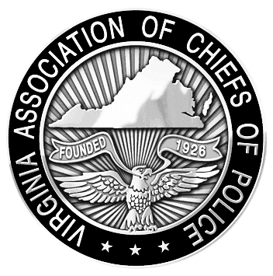
VIRGINIA ASSOCIATION OF CHIEFS OF POLICE
1606 Santa Rosa Road, Suite 134
Richmond, Virginia 23288
Phone: 804-285-8227
Fax: 804-285-3363
E-mail: dana@vachiefs.org
www.vachiefs.org
Contact: Ms. Dana Schrad, Executive Director
Mobile: (804) 338-9512

FOR RELEASE:
1:30 PM, Tuesday, August 14, 2012

2011 Virginia Law Enforcement Challenge Awards Announced
For Best Traffic Safety Programs in Virginia

The Virginia Association of Chiefs of Police (VACP) is pleased to announce the recipients of the 2011 Virginia Law Enforcement Challenge awards for the best traffic safety programs in the state. The awards luncheon took place during the VACP’s 87th Annual Training Conference on Tuesday, August 14, 2012 at the Hotel Roanoke in Roanoke, VA.
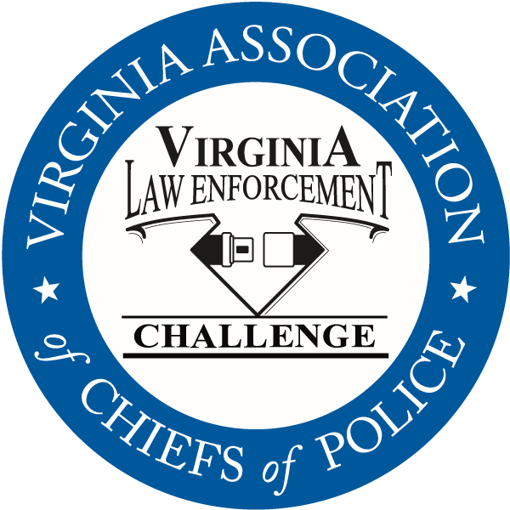
Celebrating its twenty-third year in Virginia, the Law Enforcement Challenge program promotes professionalism in traffic safety enforcement and encourages agencies to share best practices and programs with each other. The awards are based on entries prepared by the participating agencies that highlight their traffic safety education and enforcement activities in the past calendar year. Judges award points to the agencies in the six areas that comprise a comprehensive traffic safety program: an agency’s policies and guidelines, training of officers, incentives and recognition, public information and education, enforcement, and an evaluation of the effectiveness of the agency’s efforts.
The Virginia Challenge is held in cooperation with the National Law Enforcement Challenge Awards, which are presented by the International Association of Chiefs of Police (IACP). This year, forty-one Virginia agencies entered the state and national competitions. Thirty-five received state awards and eight will receive national awards. National Challenge award winners have been announced by the IACP on their web site at http://www.theiacp.org/NLEC. National awards will be presented in October at the International Association of Chiefs of Police Annual Conference in San Diego, CA.
Virginia agencies were presented with their state Challenge first, second and third place awards in each category at the luncheon in August, as well as special awards for outstanding enforcement and education efforts in the areas of occupant protection, impaired driving, speed awareness, child passenger safety, underage alcohol awareness and many more. Additionally, the VACP will announce the most outstanding traffic safety program in Virginia in 2011 regardless of agency size or type — the “Commonwealth Award” — and the 2011 Virginia Traffic Safety Officer of the Year Award, presented to an officer who has gone above and beyond to promote highway safety in his community. The Commonwealth Award recipient for 2011 is the Henrico County Division of Police and the 2011 Traffic Safety Officer of the Year is Sgt. James “Monty” Sellers of the Augusta County Sheriff’s Office.
The Virginia Law Enforcement Challenge Awards program is supported by a grant from the Virginia Highway Safety Office. Additional information about the Law Enforcement Challenge program can be found online at http://www.smartsafeandsober.org/programs/LEC.
The Virginia Association of Chiefs of Police is a statewide organization of federal, state and local police chiefs and law enforcement executives dedicated to improving the professionalism of police agencies in Virginia. The Association was founded in 1926 and has more than 600 members. For more information, visit http://www.vachiefs.org.
The winners of the 2011 Virginia Law Enforcement Challenge are as follows:
MUNICIPAL POLICE
Municipal 1: 1-10 Officers | Place
Berryville Police Department | 1
West Point Police Department | 2
Municipal 2: 11-25 Officers | Place
Bedford Police Department | 1
Ashland Police Department | 2
Purcellville Police Department | 3
Municipal 3: 26-50 Officers | Place
South Boston Police Department | 1
Culpeper Police Department | 2
Colonial Heights Police Department | 3
Municipal 4: 51-75 Officers | Place
Christiansburg Police Department | 1
Blacksburg Police Department | 2
Herndon Police Department | 3
Municipal 5: 76-125 Officers | Place
James City County Police Department  IACP National Challenge Winner: 2nd place, Municipal 5 (76-100 Officers) | 1
Harrisonburg Police Department  IACP National Challenge Winner: 3rd place, Municipal 5 (76-100 Officers) | 2
Albemarle County Police Department | 3
Municipal 6: 126-300 Officers | Place
Roanoke Police Department | 1
Lynchburg Police Department | 2
Portsmouth Police Department | 3
Municipal 7: 301-450 Officers | Place
Arlington County Police Department | 1
Newport News Police Department | 2
Municipal 8: 451-700 Officers | Place
Henrico County Division of Police  IACP National Challenge Winner: 1st place, Municipal 8 (501-1,000 Officers) | 1
Municipal 9: 701+ Officers | Place
Virginia Beach Police Department  IACP National Challenge Winner: 2nd place, Championship Class (1st place winners from previous year, regardless of size or category) & Special Award for Technology | 1
Fairfax County Police Department  IACP National Challenge Winner: 1st place, Municipal 9 (1,001 or more Officers) & Special Award for Underage Alcohol Awareness | 2

UNIVERSITY POLICE | Place
University of Richmond Police Department | 1
Virginia Commonwealth University Police Department | 2

SPECIAL ENFORCEMENT AGENCY | Place
Metro Washington Airports Authority (MWAA) Police Department  IACP National Challenge Winner: 1st place, Special Enforcement Agency | 1

SHERIFF’S OFFICES
Sheriff 1: 1-10 Deputies | Place
-- no entries in this category -- | --
Sheriff 2: 11-25 Deputies | Place
New Kent County Sheriff's Office  IACP National Challenge Winner: 2nd place, Sheriff 1 (1-25 Deputies) | 1
Sheriff 3: 26-50 Deputies | Place
Wythe County Sheriff's Office | 1
Sheriff 4: 51-75 Deputies | Place
Dinwiddie County Sheriff's Office  IACP National Challenge Winner: 3rd place, Sheriff 3 (51-100 Deputies) | 1
Augusta County Sheriff’s Office | 2
Amherst County Sheriff's Office | 3
Sheriff 5: 76-125 Deputies | Place
Washington County Sheriff's Office | 1
Fauquier County Sheriff's Office | 2
Sheriff 6: 126-300 Deputies | Place
Stafford County Sheriff's Office | 1
Hanover County Sheriff's Office | 2
Sheriff 7: 301-450 Deputies | Place
-- no entries in this category -- | --
Sheriff 8: 451-700 Deputies | Place
Loudoun County Sheriff's Office | 1

SPECIAL AWARDS
“Rookie of the Year” Award | Metro Washington Airports Authority Police Dept.
Occupant Protection Award | Fairfax County Police Department
Impaired Driving Award | Virginia Beach Police Department
Speed Awareness Award | Albemarle County Division of Police
Child Passenger Safety Award | Lynchburg Police Department
Underage Alcohol Awareness Award | Fairfax County Police Department
Technology Award | Roanoke Police Department
Bicycle/Pedestrian Safety Award | Portsmouth Police Department
Commercial Motor Vehicle Safety Award | Fairfax County Police Department
Motorcycle Safety Award | Harrisonburg Police Department
Commonwealth Award | Henrico County Division of Police
Officer of the Year Award | Sgt. James “Monty” Sellers, Augusta County Sheriff’s Office

