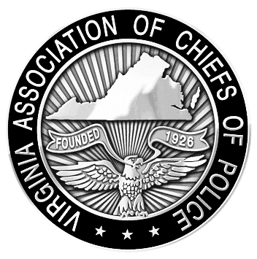
VIRGINIA ASSOCIATION OF CHIEFS OF POLICE
1606 Santa Rosa Road, Suite 134
Richmond, Virginia 23288
Phone: 804-285-8227
Fax: 804-285-3363
www.vachiefs.org

Contact: Ms. Dana Schrad, Executive Director
Mobile: (804) 338-9512; dana@vachiefs.org

Virginia Law Enforcement Challenge Awards Announced

For Best Traffic Safety Programs in Virginia in 2012

The Virginia Association of Chiefs of Police (VACP) is pleased to announce the recipients of the Virginia Law Enforcement Challenge awards for the best traffic safety programs in the state in 2012. The awards luncheon took place during the VACP’s 88th Annual Training Conference on Tuesday, August 27, 2013 at the Williamsburg Lodge in Williamsburg, VA.
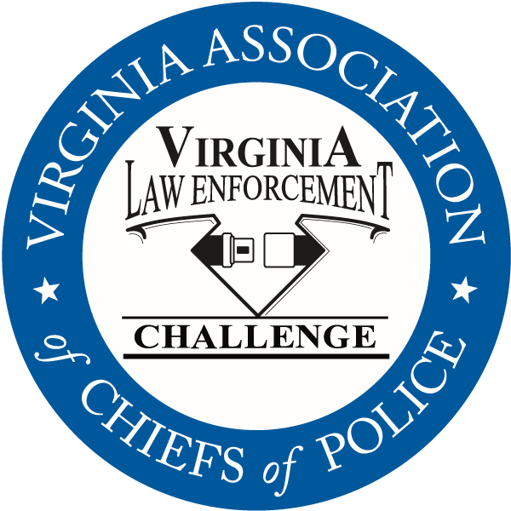
Celebrating its twenty-fourth year in Virginia, the Law Enforcement Challenge program promotes professionalism in traffic safety enforcement and encourages agencies to share best practices and programs with each other. The awards are based on entries prepared by the participating agencies that highlight their traffic safety education and enforcement activities in the past calendar year. Judges award points to the agencies in the six areas that comprise a comprehensive traffic safety program: an agency’s policies and guidelines, training of officers, incentives and recognition, public information and education, enforcement, and an evaluation of the effectiveness of the agency’s efforts.
The Virginia Challenge is held in cooperation with the National Law Enforcement Challenge Awards, which are presented by the International Association of Chiefs of Police (IACP). This year, thirty-eight Virginia agencies entered the state and national competitions. Thirty-six received state awards and sixteen will receive national awards. National Challenge award winners have been announced by the IACP on their web site at http://www.theiacp.org/NLEC. National awards will be presented in October at the International Association of Chiefs of Police Annual Conference in Philadelphia, PA.
Virginia agencies were presented with their state Challenge first, second and third place awards in each category at the luncheon, as well as special awards for outstanding enforcement and education efforts in the areas of occupant protection, impaired driving, speed awareness, child passenger safety, underage alcohol awareness and many more. Additionally, the VACP announced the most outstanding traffic safety program in Virginia in 2012 regardless of agency size or type — the “Commonwealth Award” — and the 2012 Virginia Traffic Safety Officer of the Year Award, presented to an officer who has gone above and beyond to promote highway safety in his community. The Commonwealth Award recipient for 2012 is the James City County Police Department and the 2012 Traffic Safety Officer of the Year is Police Officer First Class Michael D. Mittiga of the Fairfax County Police Department.
The Virginia Law Enforcement Challenge Awards program is supported by a grant from the Virginia Highway Safety Office. Additional information about the Law Enforcement Challenge program can be found online at http://www.smartsafeandsober.org/programs/LEC.
The Virginia Association of Chiefs of Police is a statewide organization of federal, state and local police chiefs and law enforcement executives dedicated to improving the professionalism of police agencies in Virginia. The Association was founded in 1926 and has more than 600 members. For more information, visit http://www.vachiefs.org.

PHOTOS: Go to http://photos.vachiefs.org/Law-Enforcement-Challenge/2012-Virginia-Law-Enforcement/ or contact Erin Schrad, VACP Communications Manager, at erin@vachiefs.org.
The winners of the 2012 Virginia Law Enforcement Challenge are as follows:
MUNICIPAL POLICE
Municipal 1: 1-10 Officers | Place
West Point Police Department | 1
Municipal 2: 11-25 Officers | Place
Ashland Police Department | 1
Bedford Police Department  IACP National Challenge Winner: 3rd place, Municipal 2 (11-25 Officers) | 2
Purcellville Police Department | 3
Municipal 3: 26-50 Officers | Place
Colonial Heights Police Department | 1
Culpeper Police Department | 2
Radford City Police Department | 3
Municipal 4: 51-75 Officers | Place
Herndon Police Department | 1
Christiansburg Police Department | 2
Blacksburg Police Department | 3
Municipal 5: 76-125 Officers | Place
James City County Police Department  IACP National Challenge Winner: 1st place, Municipal 5 (76-100 Officers) | 1
Albemarle County Police Department  IACP National Challenge Winner: 2nd place, Municipal 6 (101-200 Officers) | 2
Harrisonburg Police Department | 3
Municipal 6: 126-300 Officers | Place
Lynchburg Police Department | 1
Roanoke Police Department  IACP National Challenge Winner: 3rd place, Municipal 7 (201-500 Officers) | 2
Portsmouth Police Department | 3
Municipal 7: 301-450 Officers | Place
Chesapeake Police Department  IACP National Challenge Winner: 1st place, Municipal 7 (201-500 Officers) | 1
Newport News Police Department | 2
Arlington County Police Department | 3
Municipal 8: 451-700 Officers | Place
Henrico County Division of Police  IACP National Challenge Winner: 3rd place, Championship Class (category comprised of all 1st place winners from the previous year, regardless of agency size or type) | 1
Municipal 9: 701+ Officers | Place
Virginia Beach Police Department  IACP National Challenge Winner: 2nd place, Municipal 8 (501-1,000 Officers) and Special Award for Bicycle & Pedestrian Safety Efforts | 1
Fairfax County Police Department  IACP National Challenge Winner: Special Award for Commercial Motor Vehicle Safety Efforts | 2

UNIVERSITY POLICE | Place
University of Richmond Police Department | 1
Virginia Commonwealth University Police Department | 2

MILITARY POLICE | Place
Fort Lee Police  IACP National Challenge Winner: 1st place, Military | 1

SHERIFF’S OFFICES
Sheriff 1: 1-10 Deputies | Place
-- no entries in this category -- | --
Sheriff 2: 11-25 Deputies | Place
New Kent County Sheriff's Office  IACP National Challenge Winner: 1st place, Sheriff 1 (1-25 Deputies) | 1
Westmoreland County Sheriff's Office  IACP National Challenge Winner: 2nd place, Sheriff 1 (1-25 Deputies) | 2
Sheriff 3: 26-50 Deputies | Place
Amherst County Sheriff's Office  IACP National Challenge Winner: 1st place, Sheriff 2 (26-50 Deputies) | 1
Wythe County Sheriff's Office  IACP National Challenge Winner: 2nd place, Sheriff 2 (26-50 Deputies) | 2
Sheriff 4: 51-75 Deputies | Place
Augusta County Sheriff’s Office  IACP National Challenge Winner: 3rd place, Sheriff 3 (51-100 Deputies) | 1
Sheriff 5: 76-125 Deputies | Place
Washington County Sheriff's Office | 1
Fauquier County Sheriff's Office | 2
Sheriff 6: 126-300 Deputies | Place
Stafford County Sheriff's Office  IACP National Challenge Winner: 3rd place, Sheriff 4 (101-250 Deputies) | 1
Hanover County Sheriff's Office | 2

SPECIAL AWARDS
“Rookie of the Year” Award | Westmoreland County Sheriff’s Office
Occupant Protection Award | Christiansburg Police Department
Impaired Driving Award | Virginia Beach Police Department
Speed Awareness Award | Albemarle County Division of Police
Child Passenger Safety Award | Leesburg Police Department
Technology Award | Henrico County Division of Police
Bicycle/Pedestrian Safety Award | Virginia Beach Police Department
Commercial Motor Vehicle Safety Award | Fairfax County Police Department
Commonwealth Award | James City County Police Department
Officer of the Year Award | PFC Michael D. Mittiga, Fairfax County Police Department

