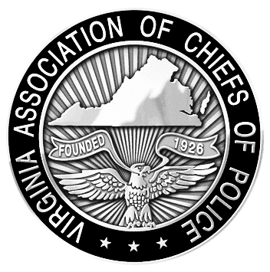
VIRGINIA ASSOCIATION OF CHIEFS OF POLICE
1606 Santa Rosa Road, Suite 134
Richmond, Virginia 23288
Phone: 804-285-8227
Fax: 804-285-3363
www.vachiefs.org
Contacts:  Ms. Dana Schrad, Executive Director  Mobile: (804) 338-9512; dana@vachiefs.org | Ms. Erin Schrad, Communications Manager  Mobile: (804) 512-5162; erin@vachiefs.org

2014 Virginia Law Enforcement Challenge Awards Announced

For Best Traffic Safety Programs in Virginia in 2013

The Virginia Association of Chiefs of Police (VACP) is pleased to announce the recipients of the Virginia Law Enforcement Challenge awards for the best traffic safety programs in the state in 2013. The awards luncheon took place during the VACP’s 89th Annual Training Conference on Tuesday, September 9 at the Hotel Roanoke in Roanoke, VA.
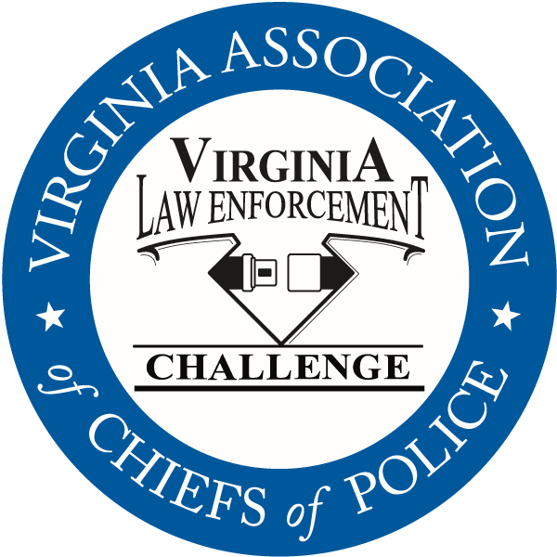
Celebrating its twenty-fifth year in Virginia, the Law Enforcement Challenge program promotes professionalism in traffic safety enforcement and encourages agencies to share best practices and programs with each other. The awards are based on entries prepared by the participating agencies that highlight their traffic safety education and enforcement activities in the past calendar year. Judges award points to the agencies in the six areas that comprise a comprehensive traffic safety program: problem identification, policies, planning, training of officers, public information and education, enforcement, and an evaluation of the outcomes of the agency’s efforts.
The Virginia Challenge is held in cooperation with the National Law Enforcement Challenge Awards, which are presented by the International Association of Chiefs of Police (IACP). This year, thirty-five Virginia agencies entered the competition, of which eight were selected to receive national awards. National Challenge award winners have been announced by the IACP on their web site at http://www.theiacp.org/NLEC. National awards will be presented in October at the International Association of Chiefs of Police Annual Conference in Orlando, FL.
The Virginia agencies listed below will be presented with their state Challenge first, second and third place awards in each category at the luncheon, as well as special awards for outstanding enforcement and education efforts in the areas of occupant protection, impaired driving, speed awareness, commercial motor vehicle safety, distracted driving, technology, bicycle/pedestrian safety, and motorcycle safety. Additionally, the VACP will present an award for the most outstanding traffic safety program in Virginia in 2013, regardless of agency size or type — the “Commonwealth Award”. The 2014 recipient of the Commonwealth Award is the Roanoke County Police Department.

The Virginia Law Enforcement Challenge Awards program is supported by a grant from the Virginia Highway Safety Office. Additional information about the Law Enforcement Challenge program can be found online at http://www.smartsafeandsober.org/programs/LEC.
The Virginia Association of Chiefs of Police is a statewide organization of federal, state and local police chiefs and law enforcement executives dedicated to improving the professionalism of police agencies in Virginia. The Association was founded in 1926 and has more than 600 members. For more information, visit http://www.vachiefs.org.

The winners of the 2014 Virginia Law Enforcement Challenge are as follows:
MUNICIPAL POLICE
Municipal 1: 1-10 Officers | Place
Saltville Police Department | 1
West Point Police Department | 2
Municipal 2: 11-25 Officers | Place
Ashland Police Department  IACP National Challenge Winner: 3rd place, Municipal 1 (1-25 Officers) | 1
Bedford Police Department | 2
Purcellville Police Department | 3
Municipal 3: 26-50 Officers | Place
Culpeper Police Department | 1
Radford City Police Department | 2
Colonial Heights Police Department | 3
Municipal 4: 51-75 Officers | Place
Herndon Police Department | 1
Salem Police Department | 2
Municipal 5: 76-125 Officers | Place
James City County Police Department | 1
Leesburg Police Department | 2
Harrisonburg Police Department | 3
Municipal 6: 126-300 Officers | Place
Roanoke County Police Department  IACP National Challenge Winner: 1st place, Municipal 3 (76-250 Officers) | 1
Roanoke Police Department  IACP National Challenge Winner: 2nd place, Municipal 3 (76-250 Officers) | 2
Portsmouth Police Department | 3 (tie)
Albemarle County Police Department | 3 (tie)
Municipal 7: 301-450 Officers | Place
Chesapeake Police Department | 1
Newport News Police Department | 2
Municipal 8: 451-700 Officers | Place
Henrico County Division of Police  IACP National Challenge Winner: 1st place, Municipal 4 (251+ Officers) | 1
Municipal 9: 701+ Officers | Place
Fairfax County Police Department | 1
Virginia Beach Police Department | 2

UNIVERSITY POLICE | Place
Virginia Commonwealth University Police Department  IACP National Challenge Winner: 1st place, College – University Law Enforcement | 1
University of Richmond Police Department | 2

SHERIFF’S OFFICES
Sheriff 1: 1-25 Deputies | Place
New Kent County Sheriff's Office  IACP National Challenge Winner: 3rd place, Sheriff 1 (1-50 Deputies) & Commercial Motor Vehicle Safety Special Award (Municipal/Sheriff) | 1
Westmoreland County Sheriff's Office  IACP National Challenge Winner: 1st place, Sheriff 1 (1-50 Deputies) & National Sheriffs’ Association  Top Traffic Safety Unit Award | 2
Sheriff 2: 26-50 Deputies | Place
Amherst County Sheriff's Office | 1
Wythe County Sheriff's Office | 2
Isle of Wight County Sheriff's Office | 3
Sheriff 3: 51-75 Deputies | Place
Gloucester County Sheriff’s Office | 1
Sheriff 4: 76-125 Deputies | Place
Fauquier County Sheriff's Office | 1
Washington County Sheriff's Office | 2
Sheriff 5: 126-300 Deputies | Place
Stafford County Sheriff's Office  IACP National Challenge Winner: 3rd place, Sheriff 2 (51-250 Deputies) | 1
Hanover County Sheriff's Office | 2

SPECIAL AWARDS
Occupant Protection Award | n/a
Impaired Driving Award | Westmoreland County Sheriff’s Office
Speed Awareness Award | Albemarle County Police Department
Technology Award | Roanoke Police Department
Bicycle/Pedestrian Safety Award | Virginia Beach Police Department
Commercial Motor Vehicle Safety Award | Fairfax County Police Department
Distracted Driving Award | New Kent County Sheriff’s Office
Motorcycle Safety Award | Harrisonburg Police Department
Commonwealth Award | Roanoke County Police Department

