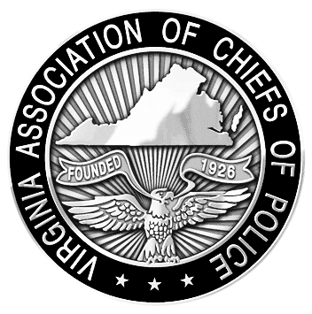
VIRGINIA ASSOCIATION OF CHIEFS OF POLICE
880 Technology Park Drive, Suite 100
Glen Allen, Virginia 23059
Phone: 804-285-8227
Fax: 804-285-3363
www.vachiefs.org
Contacts:  Ms. Dana Schrad, Executive Director  Mobile: (804) 338-9512; dana@vachiefs.org | Ms. Erin Schrad, Communications Manager  Mobile: (804) 512-5162; erin@vachiefs.org

2015 Virginia Law Enforcement Challenge Awards Announced

For Best Traffic Safety Programs in Virginia in 2014

The Virginia Association of Chiefs of Police (VACP) is pleased to announce the recipients of the Virginia Law Enforcement Challenge awards for the best traffic safety programs in the state in 2014. The awards luncheon will take place during the VACP’s 90th Annual Training Conference on Tuesday, September 1 at the Williamsburg Lodge in Williamsburg, VA.
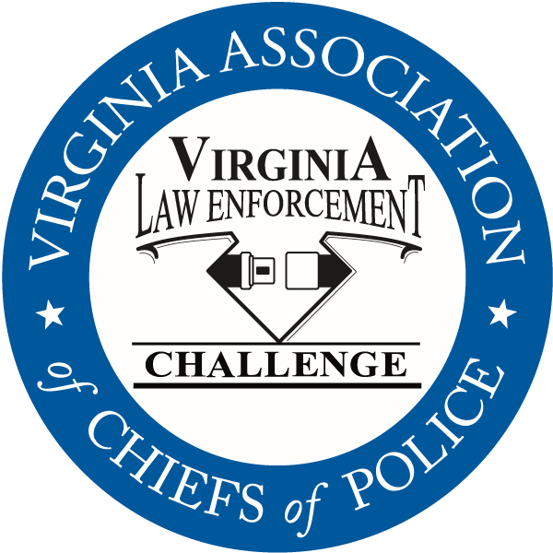
Celebrating its twenty-sixth year in Virginia, the Law Enforcement Challenge program promotes professionalism in traffic safety enforcement and encourages agencies to share best practices and programs with each other. The awards are based on entries prepared by the participating agencies that highlight their traffic safety education and enforcement activities in occupant protection, impaired driving and speed over the past calendar year. Judges award points to the agencies in the six areas that comprise a comprehensive traffic safety program: problem identification, policies, planning, training of officers, public information and education, enforcement, and an evaluation of the outcomes of the agency’s efforts.
The Virginia Challenge is held in cooperation with the National Law Enforcement Challenge Awards, which are presented by the International Association of Chiefs of Police (IACP). This year, thirty-seven Virginia agencies entered the competition, of which eleven were selected to receive thirteen national awards — the most of any state in the nation! National Challenge award winners were announced by the IACP on their web site at http://www.theiacp.org/NLEC. National awards will be presented in October at the International Association of Chiefs of Police Annual Conference in Chicago, IL.
The Virginia Association of Chiefs of Police was also selected for recognition in the National Challenge for its commitment to highway safety. The VACP will receive the State Association/Governors Highway Safety Office Award at the IACP Highway Safety Awards ceremony in Chicago.
The Virginia agencies listed below will be presented with their state Challenge first, second and third place awards in each category at the state awards luncheon, as well as special awards for outstanding enforcement and education efforts in the areas of occupant protection, impaired driving, speed awareness, commercial motor vehicle safety, distracted driving, technology, bicycle/pedestrian safety, and motorcycle safety. Additionally, the VACP will present an award for the most outstanding traffic safety program in Virginia in 2014, regardless of agency size or type — the “Commonwealth Award”.
The Virginia Law Enforcement Challenge Awards program is supported by a grant from the Virginia Highway Safety Office. Additional information about the Law Enforcement Challenge program can be found online at http://www.smartsafeandsober.org/programs/LEC.
The Virginia Association of Chiefs of Police is a statewide organization of federal, state and local police chiefs and law enforcement executives dedicated to improving the professionalism of police agencies in Virginia. The Association was founded in 1926 and has more than 600 members. For more information, visit http://www.vachiefs.org.

The winners of the 2015 Virginia Law Enforcement Challenge are as follows:
MUNICIPAL POLICE
Municipal 1: 1-20 Officers | Place
Bedford Police Department | 1
Saltville Police Department | 2
Municipal 2: 21-45 Officers | Place
Ashland Police Department  IACP National Challenge Winner: 2nd place, Municipal 1 (1-25 Officers) | 1
Culpeper Police Department | 2
Radford Police Department | 3
Municipal 3: 46-60 Officers | Place
Herndon Police Department | 1
Christiansburg Police Department | 2
Municipal 4: 61-125 Officers | Place
Albemarle County Police Department | 1
Harrisonburg Police Department | 2
Salem Police Department | 3
Municipal 5: 126-250 Officers | Place
Roanoke Police Department  IACP National Challenge Winner: 1st place, Municipal 3 (76-250 Officers) | 1
Roanoke County Police Department  IACP National Challenge Winner: 2nd place, Municipal 3 (76-250 Officers) & Speed Awareness Special Award | 2
Lynchburg Police Department | 3
Municipal 6: 251-425 Officers | Place
Arlington County Police Department  IACP National Challenge Winner: 2nd place, Municipal 4 (251 or More Officers) | 1
Chesapeake Police Department | 2
Newport News Police Department | 3
Municipal 7: 426-650 Officers | Place
Henrico County Division of Police  IACP National Challenge Winner: Commercial Motor Vehicle Special Award | 1
Chesterfield County Police Department | 2
Municipal 8: 651 or More Officers | Place
Virginia Beach Police Department  IACP National Challenge Winner: 1st place, Municipal 4 (251 or More Officers) | 1
Fairfax County Police Department  IACP National Challenge Winner: 3rd place, Municipal 4 (251 or More Officers) | 2

SPECIAL LAW ENFORCEMENT | Place
Metro Washington Airports Authority Police Department  IACP National Challenge Winner: 2nd place, Special Law Enforcement | 1

UNIVERSITY POLICE | Place
Virginia Commonwealth University Police Department | 1
University of Richmond Police Department | 2

SHERIFF’S OFFICES
Sheriff 1: 1-20 Deputies | Place
no entries | --
Sheriff 2: 21-45 Deputies | Place
New Kent County Sheriff's Office  IACP National Challenge Winner: 1st place, Sheriff 1 (1-50 Deputies) | 1
Westmoreland County Sheriff's Office  IACP National Challenge Winner: 3rd place, Sheriff 1 (1-50 Deputies) | 2
Wythe County Sheriff's Office | 3
Sheriff 3: 46-60 Deputies | Place
Gloucester County Sheriff’s Office | 1
Amherst County Sheriff's Office | 2
Sheriff 4: 61-125 Deputies | Place
Fauquier County Sheriff's Office | 1
Washington County Sheriff's Office | 2
Sheriff 5: 126-250 Deputies | Place
Stafford County Sheriff's Office  IACP National Challenge Winner: 3rd place, Sheriff 2 (51-250 Deputies) & Traffic Incident Management Special Award | 1
Hanover County Sheriff's Office | 2
Sheriff 6: 251-425 Deputies | Place
no entries | --
Sheriff 7: 426-650 Deputies | Place
no entries | --
Sheriff 8: 651 or More Deputies | Place
no entries | --

SPECIAL AWARDS
Occupant Protection Award | Roanoke Police Department
Impaired Driving Award | Virginia Beach Police Department
Speed Awareness Award | Roanoke County Police Department
Motorcycle Safety Award | Harrisonburg Police Department
Technology Award | --
Distracted Driving Award | New Kent County Sheriff’s Office
Bicycle/Pedestrian Safety Award | Albemarle County Police Department
Commercial Motor Vehicle Safety Award | Henrico County Division of Police
Traffic Incident Management | Stafford County Sheriff’s Office
Commonwealth Award | TBA

