VIRGINIA ASSOCIATION OF CHIEFS OF POLICE
880 Technology Park Drive, Suite 100
Glen Allen, Virginia 23059
Phone: 804-285-8227
Fax: 804-285-3363
www.vachiefs.org
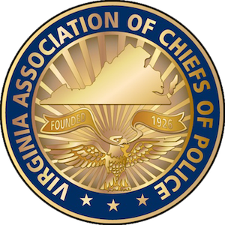
Contacts:  Ms. Dana Schrad, Executive Director  Mobile: (804) 338-9512; dana@vachiefs.org | Ms. Erin Schrad, Communications Manager  Mobile: (804) 512-5162; erin@vachiefs.org

2016 Virginia Law Enforcement Challenge Awards Announced

For Best Traffic Safety Programs in Virginia in 2015

The Virginia Association of Chiefs of Police (VACP) is pleased to announce the recipients of the 2016 Virginia Law Enforcement Challenge awards for the best traffic safety programs in the state in 2015. The awards luncheon took place during the VACP’s 91st Annual Training Conference on Tuesday, September 20 at the Hotel Roanoke in Roanoke, VA.
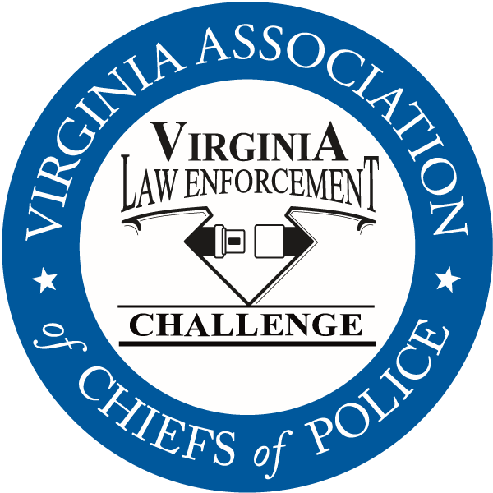
Celebrating its twenty-seventh year in Virginia, the Law Enforcement Challenge program promotes professionalism in traffic safety enforcement and encourages agencies to share best practices and programs with each other. The awards are based on entries prepared by the participating agencies that highlight their traffic safety education and enforcement activities in occupant protection, impaired driving and speed over the past calendar year. Judges award points to the agencies in the six areas that comprise a comprehensive traffic safety program: problem identification, policies, planning, training of officers, public information and education, enforcement, and an evaluation of the outcomes of the agency’s efforts.
The Virginia agencies listed below were presented with their Virginia Challenge first, second and third place awards in each category at the state awards luncheon, as well as special awards for outstanding enforcement and education efforts in the areas of occupant protection, impaired driving, speed awareness, commercial motor vehicle safety, distracted driving, technology, bicycle/pedestrian safety, and motorcycle safety. Additionally, the VACP presented Westmoreland County Sheriff’s Office with the “Commonwealth Award” for the most outstanding traffic safety program in Virginia in 2015, regardless of agency size or type.
The Virginia Challenge is held in cooperation with the National Law Enforcement Challenge Awards, which are presented by the International Association of Chiefs of Police (IACP) — see http://www.theiacp.org/NLEC. This year, thirty Virginia agencies entered the Challenge, of which eleven were selected to receive national awards — the most of any state in the nation! The Virginia Association of Chiefs of Police was also selected for recognition in the National Challenge for its commitment to highway safety and will receive the State Association/Governors Highway Safety Office Award. National awards will be presented October 18 at the International Association of Chiefs of Police Annual Conference in San Diego, CA.
The Virginia Law Enforcement Challenge Awards program is supported by a grant from the Virginia Highway Safety Office. Additional information about the Law Enforcement Challenge program can be found online at http://www.smartsafeandsober.org/programs/LEC.
The Virginia Association of Chiefs of Police & Foundation is a statewide organization of federal, state and local police chiefs and law enforcement executives dedicated to improving the professionalism of police agencies in Virginia. The Association was founded in 1926 and has more than 600 members. For more information, visit http://www.vachiefs.org.

The winners of the 2016 Virginia Law Enforcement Challenge are as follows:
MUNICIPAL POLICE
Municipal 1: 1-20 Officers | Place
Saltville Police Department | 1
Municipal 2: 21-40 Officers | Place
Ashland Police Department  IACP National Challenge Winner: 2nd place, Municipal 2 (21-50 Officers) | 1
Radford Police Department | 2
Bedford Police Department | 3
Municipal 3: 41-55 Officers | Place
Herndon Police Department | 1
Culpeper Police Department | 2
Colonial Heights Police Department | 3
Municipal 4: 56-125 Officers | Place
Harrisonburg Police Department | 1
Christiansburg Police Department | 2
Salem Police Department | 3
Municipal 5: 126-225 Officers | Place
Roanoke County Police Department  IACP National Challenge Winner: 2nd place, Municipal 4 (101-350 Officers) | 1
Lynchburg Police Department | 2
Albemarle County Police Department | 3
Municipal 6: 226-400 Officers | Place
Roanoke Police Department  IACP National Challenge Winner: 3rd place, Municipal 4 (101-350 Officers) | 1
Arlington County Police Department  IACP National Challenge Winner: 3rd place, Municipal 5 (351 or More Officers) | 2
Chesapeake Police Department | 3
Municipal 7: 401-650 Officers | Place
Henrico County Division of Police  IACP National Challenge Winner: 1st place, Municipal 5 (351 or More Officers) | 1
Municipal 8: 651 or More Officers | Place
Virginia Beach Police Department  IACP National Challenge Winner: 2nd place, Municipal 5 (351 or More Officers) & Bike/Ped Safety Award | 1
Fairfax County Police Department | 2

UNIVERSITY POLICE | Place
Virginia Commonwealth University Police Department | 1
University of Richmond Police Department | 2

SPECIAL LAW ENFORCEMENT | Place
Metro Washington Airports Authority Police Department  IACP National Challenge Winner: 1st place, Special Law Enforcement | 1

MILITARY POLICE | Place
Fort Eustis Police Department  IACP National Challenge Winner: 3rd place, Military | 1
Fort Lee Police Department | 2

SHERIFF’S OFFICES
Sheriff 1: 1-20 Deputies | Place
no entries | --
Sheriff 2: 21-40 Deputies | Place
Westmoreland County Sheriff's Office  IACP National Challenge Winner: 1st place, Sheriff 1 (1-50 Deputies) | 1
New Kent County Sheriff's Office | 2
Sheriff 3: 41-80 Deputies | Place
no entries | --
Sheriff 4: 81-160 Deputies | Place
Gloucester County Sheriff's Office  IACP National Challenge Winner: 1st place, Sheriff 2 (51-150 Deputies) | 1
Fauquier County Sheriff's Office | 2
Sheriff 5: 161-300 Deputies | Place
Hanover County Sheriff's Office  IACP National Challenge Winner: 3rd place, Sheriff 3 (151 or More Deputies) | 1
Stafford County Sheriff's Office | 2
Sheriff 6: 301 or More Deputies | Place
no entries | --

SPECIAL AWARDS
Occupant Protection Award | Roanoke County Police Department
Impaired Driving Award | Ashland Police Department
Speed Awareness Award | Roanoke Police Department
Motorcycle Safety Award | Harrisonburg Police Department
Technology Award | Culpeper Police Department
Distracted Driving Award | Metro Washington Airports Authority Police Department
Bicycle/Pedestrian Safety Award | Virginia Beach Police Department
Commercial Motor Vehicle Safety Award | Fort Eustis Police
Traffic Incident Management | Fairfax County Police Department
Commonwealth Award | Westmoreland County Sheriff’s Office

