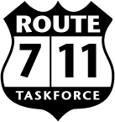
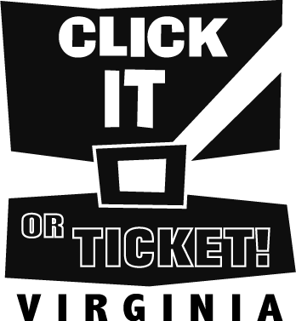

Report Date: / /

2012 Law Enforcement Activities Report Form

Section 1 Complete Administrative Information:

Jurisdiction Name:

Site Coordinator:

Email Address of Person Submitting This Form:

Contact Phone Number (with area code):

Section 2 Campaign Start Date End Date Route #:

If seat belt surveys were conducted, please provide the usage percentage:

Pre Survey: Post Survey:

Section 3 Complete ALL Fields: (While working on Federal Grants, “ZERO” tolerance is expected)
These numbers should reflect the totals for all officers during this event timeframe.
Enter A Number For Each Field, even if ”0”
Total Number of Officers Participating  Total Number of Man hours  Speeding Violations Speeding Violations  Reckless Driving  All Other Traffic Violations  Driving Under Influence of Intoxicants | Misdemeanor Arrest  Felony Arrest  Child Safety Seat Violations  Safety Belt Violations  CPS Installations Made By Officers  Commercial Motor Vehicle Violations

Section 4 Please report any unusual activities in your jurisdiction that may be of interest
to the media and public.

Revised 4-20-12
PLEASE EMAIL THIS REPORT TO CLICKITORTICKET@AOL.COM

