By the
[INSERT TITLE OF LOCAL OFFICIAL OR GOVERNING BODY]
of
[INSERT CITY/TOWN/COUNTY]
WHEREAS, the safety and security of the citizens of [city/county/town] and surrounding areas are vitally important;
WHEREAS, a large percentage of our citizens regularly drive or ride in motor vehicles on our roadways;
WHEREAS, the use of seat belts in passenger vehicles saved an estimated 12,174 lives in 2012 and 63,000 lives since 2008;
WHEREAS, regular seat belt use is the single most effective way to reduce injuries and fatalities in motor vehicle crashes;
WHEREAS, the use of seat belts is supported by the laws of the Commonwealth of Virginia;
WHEREAS, May 19 through June 1, 2014, has been selected as the national Click It or Ticket mobilization enforcement period;
WHEREAS, across the country law enforcement officers will actively be participating in the mobilization to ensure all motor vehicle occupants are buckled up during the day and night to reduce the risk of injury and death caused in traffic crashes;
AND WHEREAS, increased enforcement of seat belt laws coupled with increased awareness has proven to be an effective method to increase seat belt use rates and decrease fatal crashes.
NOW, THEREFORE, BE IT RESOLVED, THAT [local governing body], does hereby proclaim and announce May 19 to June 1, 2014, as the Click It or Ticket Mobilization in [city/county/town], and urge all citizens to always wear seat belts whenever driving or riding on our roadways.

IN WITNESS WHEREOF, I have hereunto set my hand on behalf of [city/county/town].

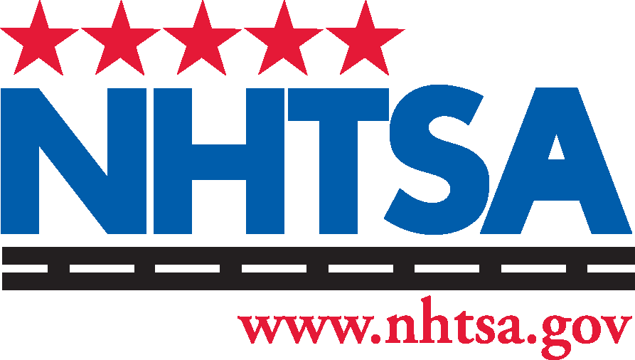
______________________________________
[Name, Title, Jurisdiction]
______________________________________
[Date]

