[Your agency’s or locality’s logo]

FOR IMMEDIATE RELEASE
June X, 2015
Contact: Your agency’s contact person
Phone
Email address

Click It or Ticket Mobilization Strives to Save Lives
Officers Report Robust Results for Two-Week Effort

Law enforcement officers from [your department/office] worked more than [number] hours of overtime during the recent, two-week Click It or Ticket mobilization. They issued [number] safety belt citations, [number] child safety seat citations, [number] speeding tickets and [number] reckless driving citations; [number] DUI drivers were removed off the road and [number] juveniles were cited for underage drinking. In addition, [number] stolen vehicles were recovered, [number] fugitives were apprehended, [number] drug arrests were made and [number] weapons were seized.
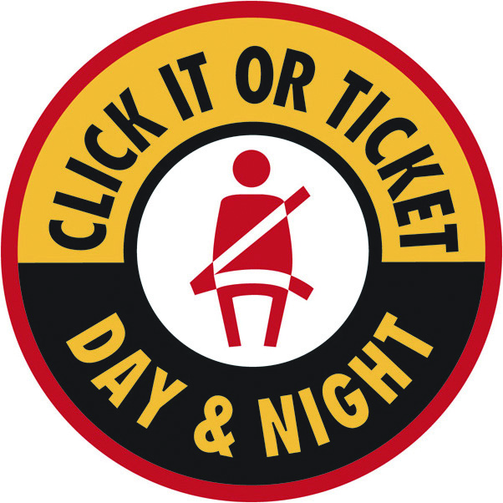
More than 500 local law enforcement officers and Virginia state troopers participated in the annual Click It campaign, which focuses on seat belt and child safety seat violations in an effort to prevent traffic deaths.
“We’d like everyone to buckle up voluntary and comply with the law, but if they don’t, we will issue them a citation that may save their life in the future,” said [local spokesperson]. “Seat belts are the single most effective traffic safety device for preventing death during a crash.”
Virginia law requires all front seat occupants of motor vehicles be restrained, and any passenger from birth to 18 years old be properly restrained in an appropriate child safety seat or seat belt. Virginia law also requires that rear-facing child restraint devices be placed in the back seat of a vehicle. “It’s the law in Virginia to wear your seat belt and make sure children are in a car seat, and doing so will save your life during a crash,” said [local spokesperson].
The next national and statewide Click It or Ticket mobilization will be during the last week in November as part of the Thanksgiving holiday. Virginia’s law enforcement officers and those across the country will again emphasize seat belt and child safety seat violations during this time period in an effort to prevent future traffic deaths.
Virginia’s statewide seat belt use rate was 77.3 percent in 2014, 79.7 percent in 2013 and 78.4 percent in 2012. Last year in Virginia, 52 percent of all traffic fatalities, or 256 deaths, were unrestrained drivers and passengers.
According to the National Highway Traffic Safety Administration, seat belts really do save lives. From 2008 to 2012, they saved nearly 63,000 lives nationwide. And in 2012 in the United States, an additional 3,031 lives could have been saved if all unrestrained occupants involved in fatal crashes had worn their seat belts.
###

